Installing Jenkins on Ubuntu

**One Ubuntu 16.04 server** configured with a non-root sudo user and a firewall by following the [Ubuntu 16.04 initial server setup guide](https://www.digitalocean.com/community/tutorials/initial-server-setup-with-ubuntu-16-04). We recommend starting with at least 1 GB of RAM. See [Choosing the Right Hardware for Masters](https://jenkins.io/doc/book/hardware-recommendations/) for guidance in planning the capacity of a production Jenkins installation.

When the server is set up, you're ready to follow along.

Step 1 — Installing Jenkins

The version of Jenkins included with the default Ubuntu packages is often behind the latest available version from the project itself. In order to take advantage of the latest fixes and features, we'll use the project-maintained packages to install Jenkins.

First, we'll add the repository key to the system.

* wget -q -O - https://pkg.jenkins.io/debian/jenkins-ci.org.key | sudo apt-key add -

When the key is added, the system will return OK. Next, we'll append the Debian package repository address to the server's sources.list:

* echo deb http://pkg.jenkins.io/debian-stable binary/ | sudo tee /etc/apt/sources.list.d/jenkins.list

When both of these are in place, we'll run update so that apt-get will use the new repository:

* sudo apt-get update

Finally, we'll install Jenkins and its dependencies, including Java:

* sudo apt-get install jenkins

Now that Jenkins and its dependencies are in place, we'll start the Jenkins server.

Step 2 — Starting Jenkins

Using systemctl we'll start Jenkins:

sudo systemctl start jenkins

Since systemctl doesn't display output, we'll use its status command to verify that it started successfully:

* sudo systemctl status jenkins

If everything went well, the beginning of the output should show that the service is active and configured to start at boot:

Output

● jenkins.service - LSB: Start Jenkins at boot time

Loaded: loaded (/etc/init.d/jenkins; bad; vendor preset: enabled)

Active:active (exited) since Thu 2017-04-20 16:51:13 UTC; 2min 7s ago

Docs: man:systemd-sysv-generator(8)

Now that Jenkins is running, we'll adjust our firewall rules so that we can reach Jenkins from a web browser to complete the initial set up.

Step 3 — Opening the Firewall

By default, Jenkins runs on port 8080, so we'll open that port using ufw:

## Step 3 — Setting up Jenkins

To set up our installation, we'll visit Jenkins on its default port, 8080, using the server domain name or IP address: http://ip_address_or_domain_name:8080

We should see "Unlock Jenkins" screen, which displays the location of the initial password

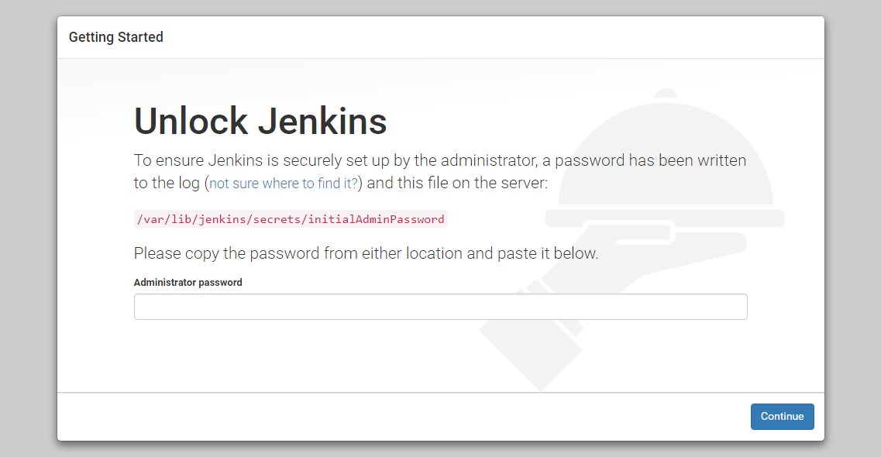

In the terminal window, we'll use the cat command to display the password:

* sudo cat /var/lib/jenkins/secrets/initialAdminPassword

We'll copy the 32-character alphanumeric password from the terminal and paste it into the "Administrator password" field, then click "Continue". The next screen presents the option of installing suggested plugins or selecting specific plugins.

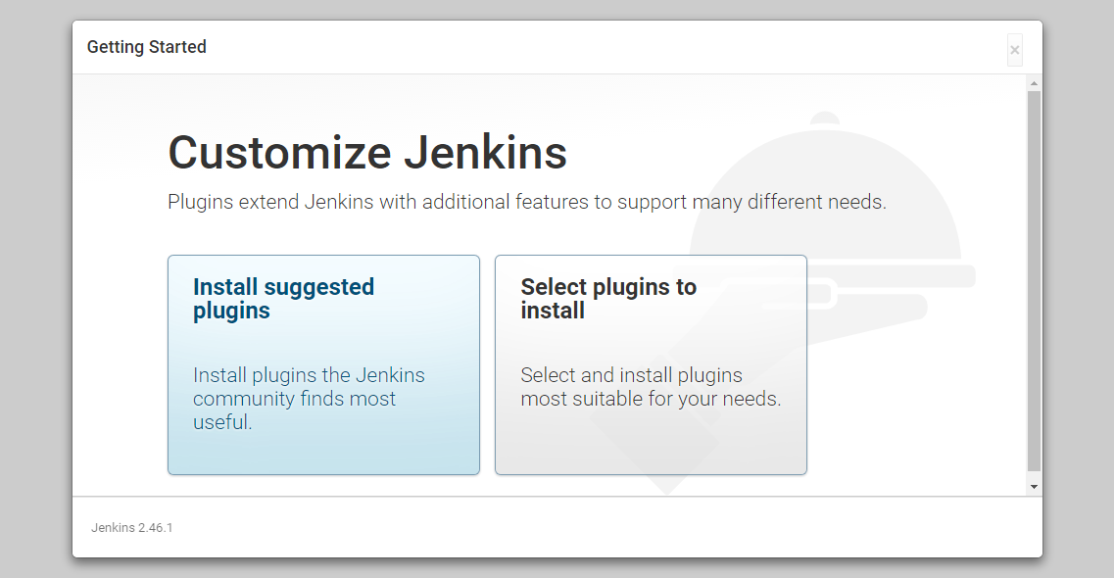

We'll click the "Install suggested plugins" option, which will immediately begin the installation process:

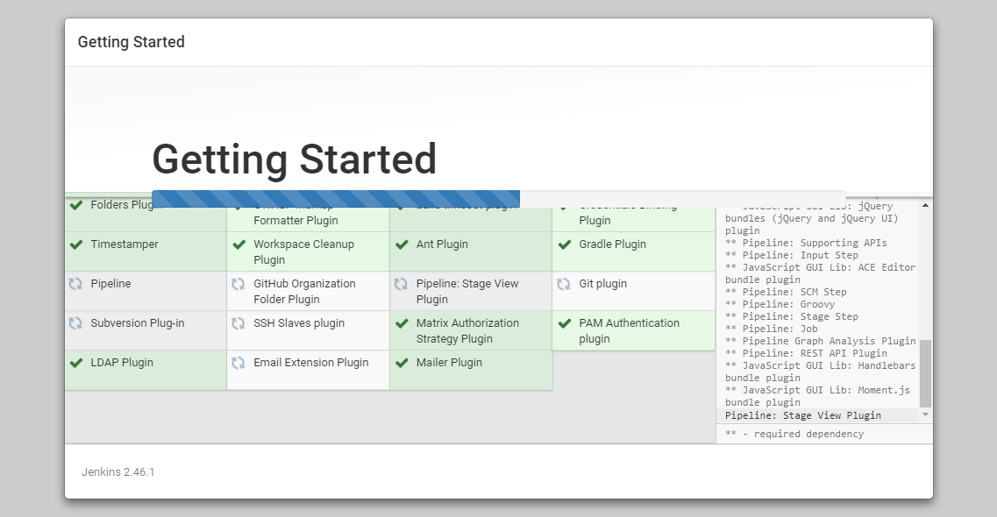

When the installation is complete, we'll be prompted to set up the first administrative user. It's possible to skip this step and continue as admin using the initial password we used above, but we'll take a moment to create the user.

**Note:** The default Jenkins server is NOT encrypted, so the data submitted with this form is not protected. When you're ready to use this installation, follow the guide [How to Configure Jenkins with SSL using an Nginx Reverse Proxy](https://www.digitalocean.com/community/tutorials/how-to-configure-jenkins-with-ssl-using-an-nginx-reverse-proxy). This will protect user credentials and information about builds that are transmitted via the Web interface.

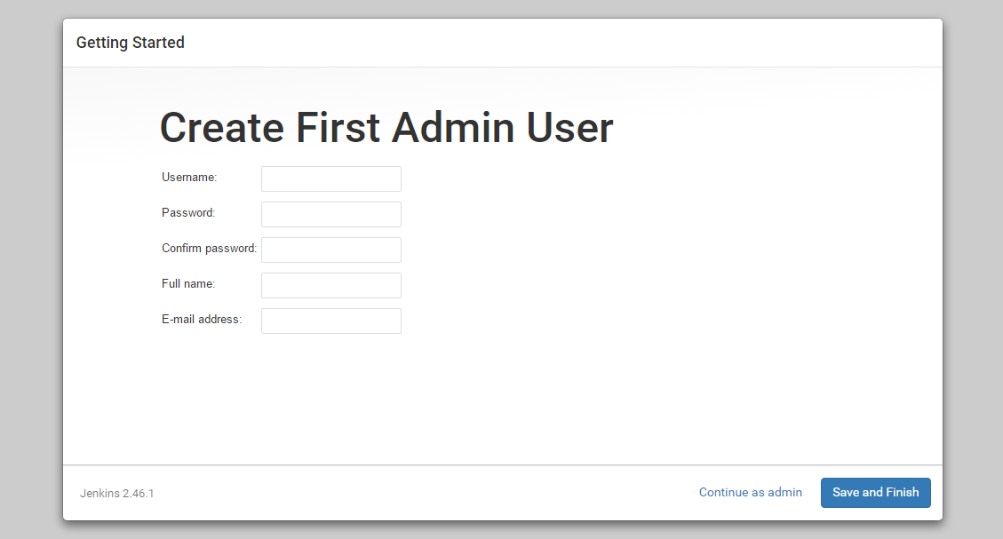

Once the first admin user is in place, you should see a "Jenkins is ready!" confirmation screen.

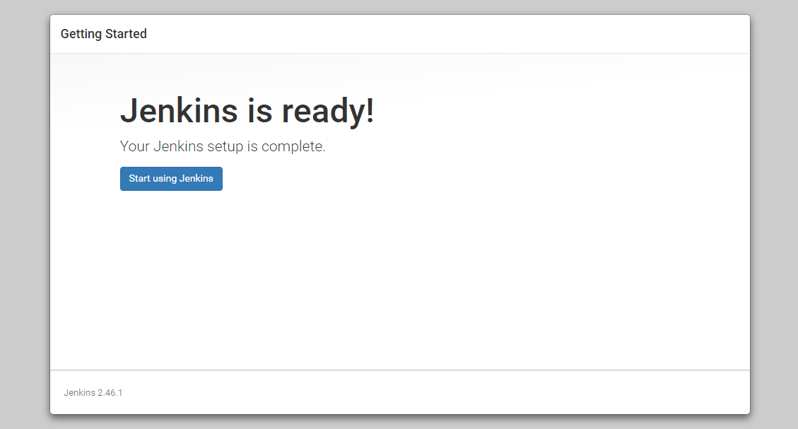  
Click "Start using Jenkins" to visit the main Jenkins dashboard:

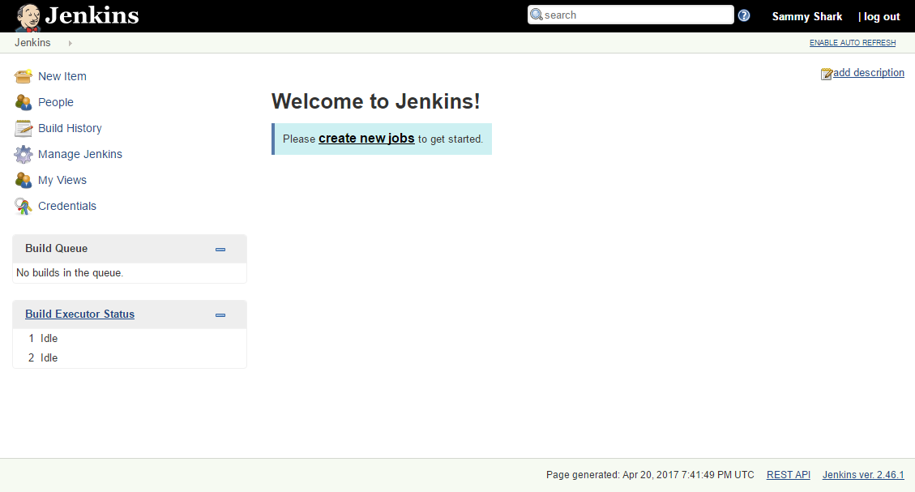

At this point, Jenkins has been successfully installed.